**System requirements:**

Visidome is a company that manufactures eye transplant lenses, they want to add to their testing unit an automation device that allows controlling multiple stepper motors and measuring device. the motors are used to move the lenses up and down as an elevator

1. **Controlling the steppers**

The user wants a GUI that can show up to 6 motors, and he wants to be able to move all of them at once at the same rate. And also be able to calibrate and move each one independently.

1. **Sensors integration**

the user wants to be able to read the laser sensors and show their output in the GUI.Each Stage has its own stepper motor and a laser sensor.

**Background:**

* Stepper motor:

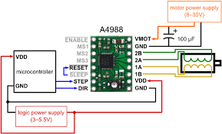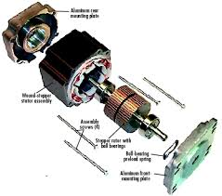

* Stage

